If you are a new applicant to this granting system, please use the technical guides below to:

- Register by creating a new account
- Apply for grants
- Manage your media library and attach files to applications, interim, or final reports
- Complete application processes
- Find additional help

TABLE OF CONTENTS
CREATE A NEW ACCOUNT 2
BEGIN AN APPLICATION 3
WORK ON AN EXISTING APPLICATION 4
MULTIPLE SUBMISSION PAGE 5
MEDIA LIBRARY SELECTION PAGE 6
MEDIA LIBRARY 7
NEXT STEPS 8
HELP AND GUIDANCE 9

*If you are viewing this document in a web browser, you may need to open or download it as a PDF for the Table of Contents and other links to work.

CREATE A NEW ACCOUNT

In order to utilize our online granting system, you will need to create an account. You will be able to access our home page when you first navigate to our site; however, if you leave the home page, you will be prompted to login. You will be able to view Additional Resource pages if they exist, but you will not be able to edit your profile, access applications, or manage your media until you create an account and/or log in.
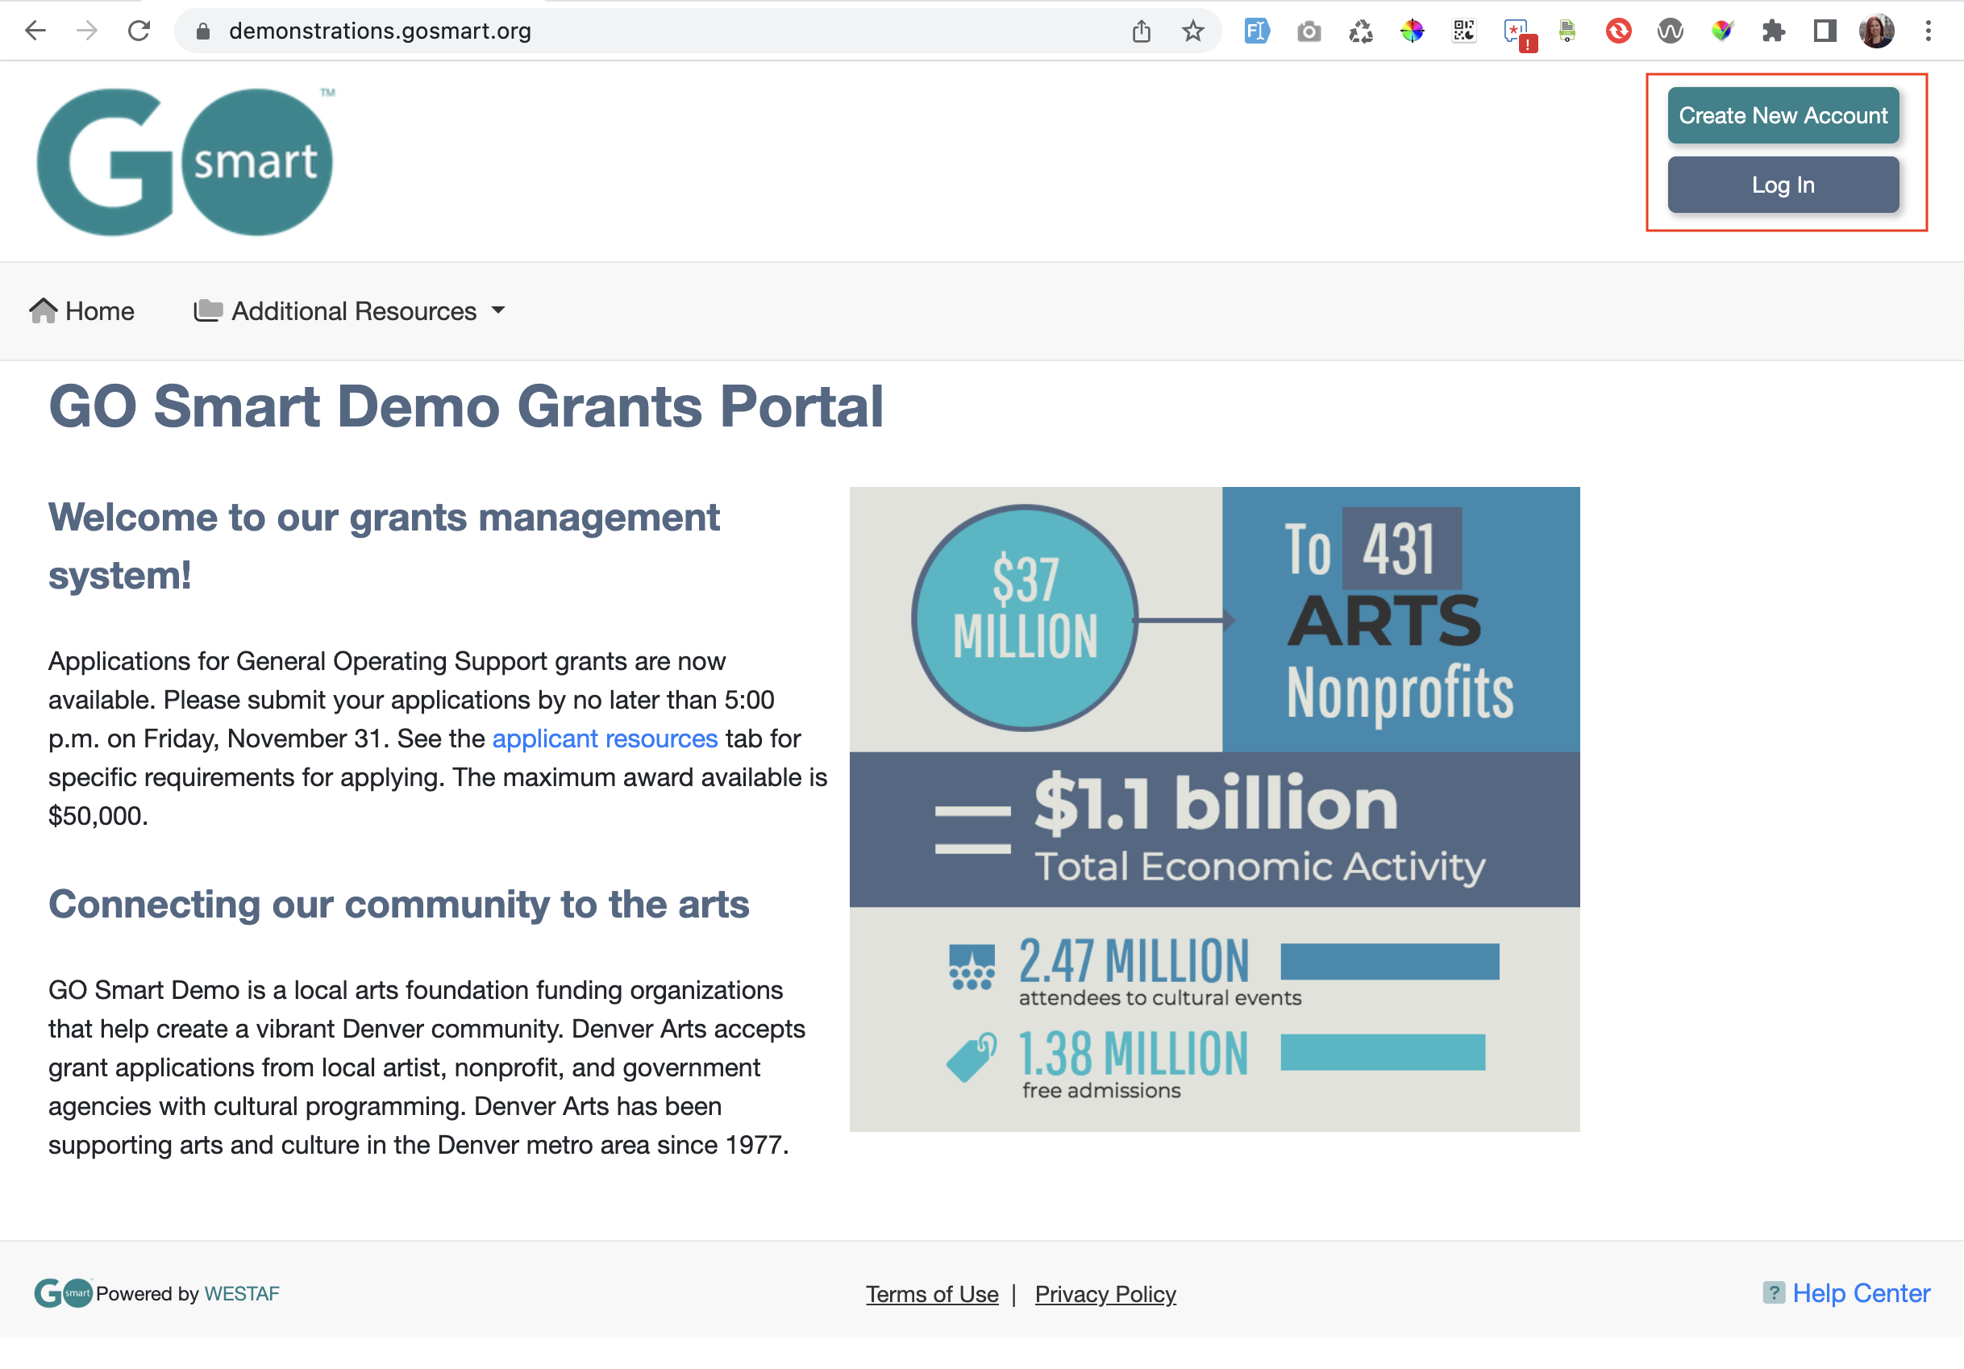
- Navigate to the GO Smart portal at the URL that was provided to you.

- Locate the Create New Account button at the top right corner.

- Answer the questions on the registration page and click Submit to create your account.

- If you want multiple people to work on a single application, they will all need to login with the same username and password.

- You can always update any information of your profile. Once logged in, click Edit Profile in your navigation bar to access and edit your registration information.

- If you forget your username or password, click the Log In button and use the retrieval tools linked from the Log In page.

- Continue to log in with your existing account rather than creating multiple accounts unless your granting agency recommends you do so.

BEGIN AN APPLICATION

When you are ready to work on an application, you will use your Grant Application & Forms tab to find the appropriate application(s).
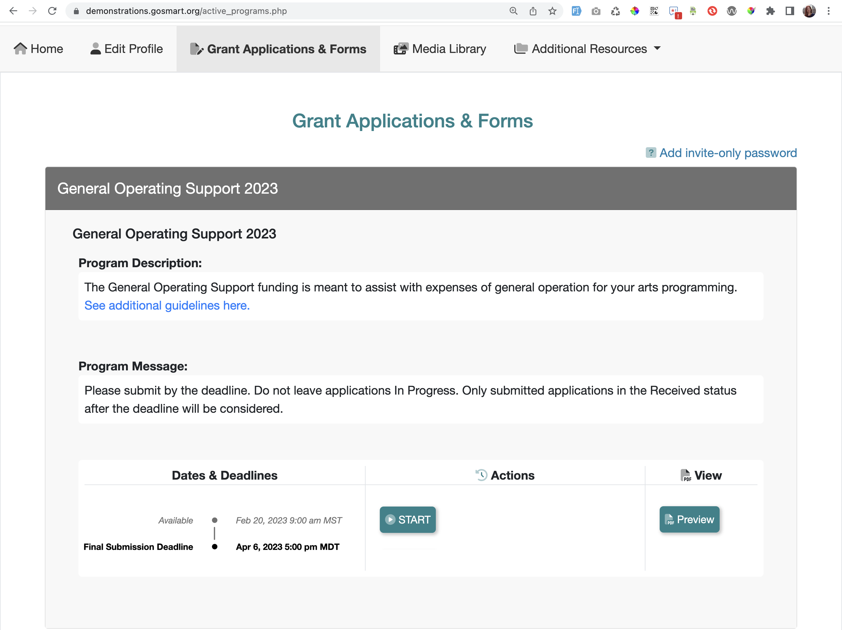
- Log in and navigate to the Grant Applications & Forms tab to begin working on your application, or optional forms such as your intent to apply, interim, quarterly reports, final report, etc.

- Scroll through your list of available grant programs, noting the name in the gray heading along the top of each box (such as General Operating Support 2023 in the example above).

- Learn more about the program by reading the included description and/or message.

- If the application is currently available to you, click the START button to begin working on the form. If the cycle includes an Intent to Apply, click START Intent to Apply. If the cycle is not yet available, you can click on the Preview button to view a read-only version. If you have missed the deadline, you will not see any action buttons available to you at this time. A deadline displayed in red is approaching within 72 hours.

WORK ON AN EXISTING APPLICATION

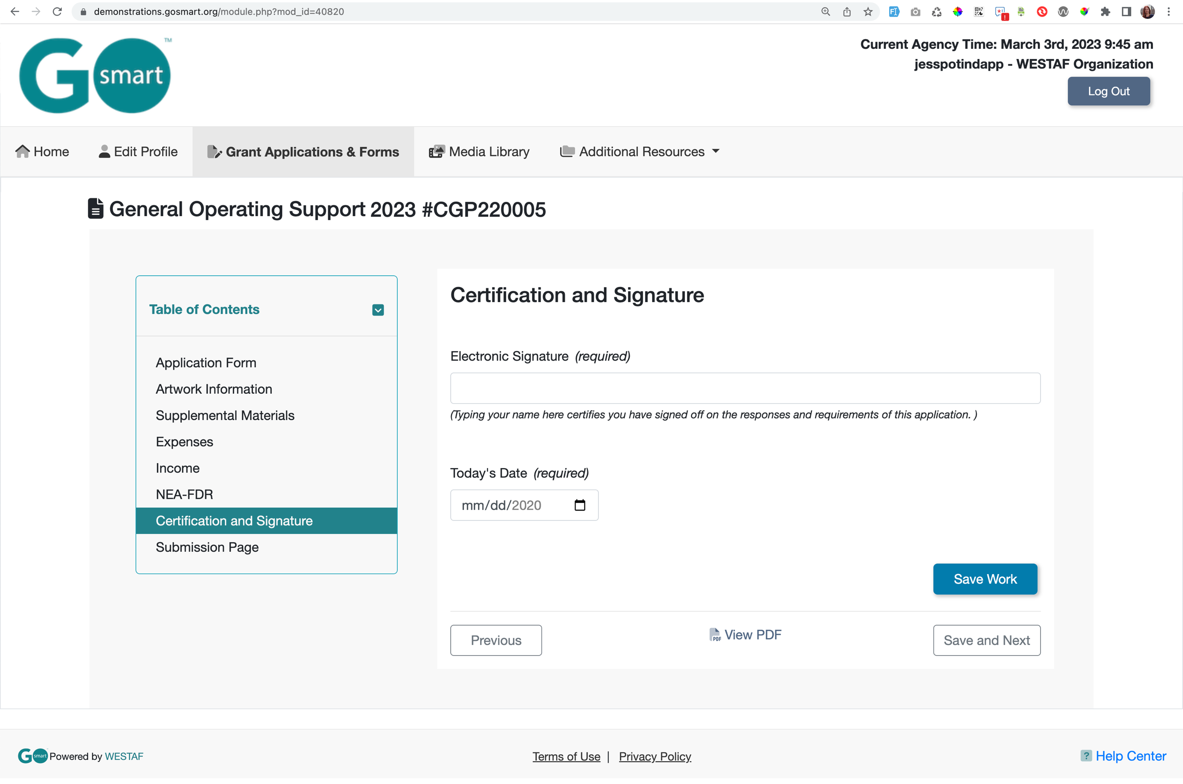
- Log in and navigate to your grant program from the Grant Applications & Forms tab. Click the EDIT button for the application form you have begun and want to continue working on.

- Navigate through the form by using the Table of Contents OR by using the Previous and Next buttons at the bottom of the page. Your application will look different than the short example above. Close the Table of Contents if desired by clicking the small down arrow.

- Answer the questions and click the “Save and Next” button to save your work and advance to the next page.

- Where available, click the "Save Work” button at the bottom of the page to check if any required item was not answered.

- You must click Save Work or Save and Next at the bottom of EVERY page before clicking Previous, clicking the title of a different page in the Table of Contents, or leaving the page.

- Use the View PDF link at the bottom of any page to view your application exactly as admin and panelists will view your application.

- Submit your form on the “Submission Page”. Once you submit the item it becomes read-only and can only be edited upon request to your granting agency.
multiple submission

MULTIPLE SUBMISSION PAGE

You may see a page in your application form that allows you to submit a set of questions more than once. If you see the following: “Custom Narrative Settings. This page accepts multiple answer sets…” you are on a Multiple Submissions page. Your granting agency will create custom questions and will determine the number of times or range in which you should submit this set. You will see this range, minimum, maximum, or exact amount in the informational text.
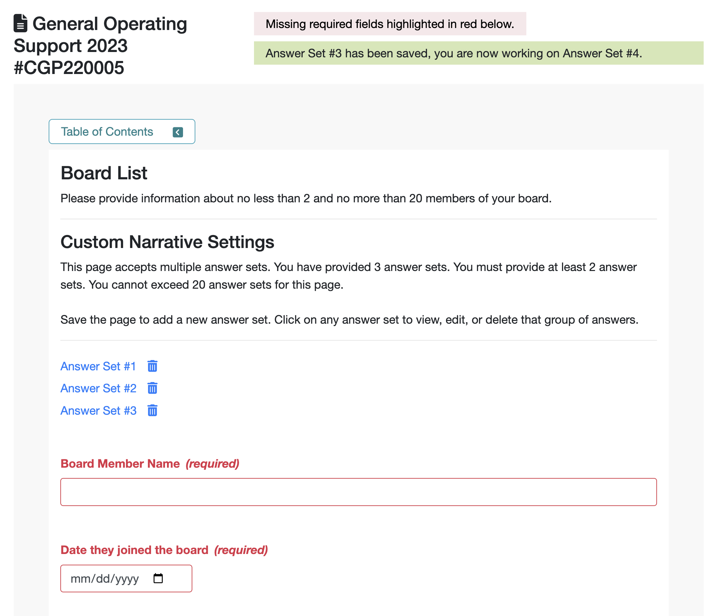
- Complete your first set of responses.

- Click Save Work if you would like to complete and save additional sets of responses. See your saved sets listed above the questions as “Answer Set #X”. Review and edit the set by clicking the link.

- Click Save and Next after you have entered responses for your final desired set.

- If you click Save Work after entering your final set, you will be on a new form that is waiting for additional responses. Clicking Save and Next from a blank form will save that empty set and you will likely need to delete it from the list of saved answer sets.

- If your set has required questions, you will see those questions highlighted in red after you click Save Work. This does not indicate that this question is unanswered in your previous set(s).

MEDIA LIBRARY SELECTION PAGE

You may see a page within your application that gives you the opportunity to use an Attach [Media] button, as shown in the example below. If you see these buttons you are on a Media Library Selection page. In order to utilize this page, you will need to upload files to your Media Library that you will then attach to this page. Within the application, this page may be called Media Attachments or something similar such as Support Materials, Work Samples, etc.
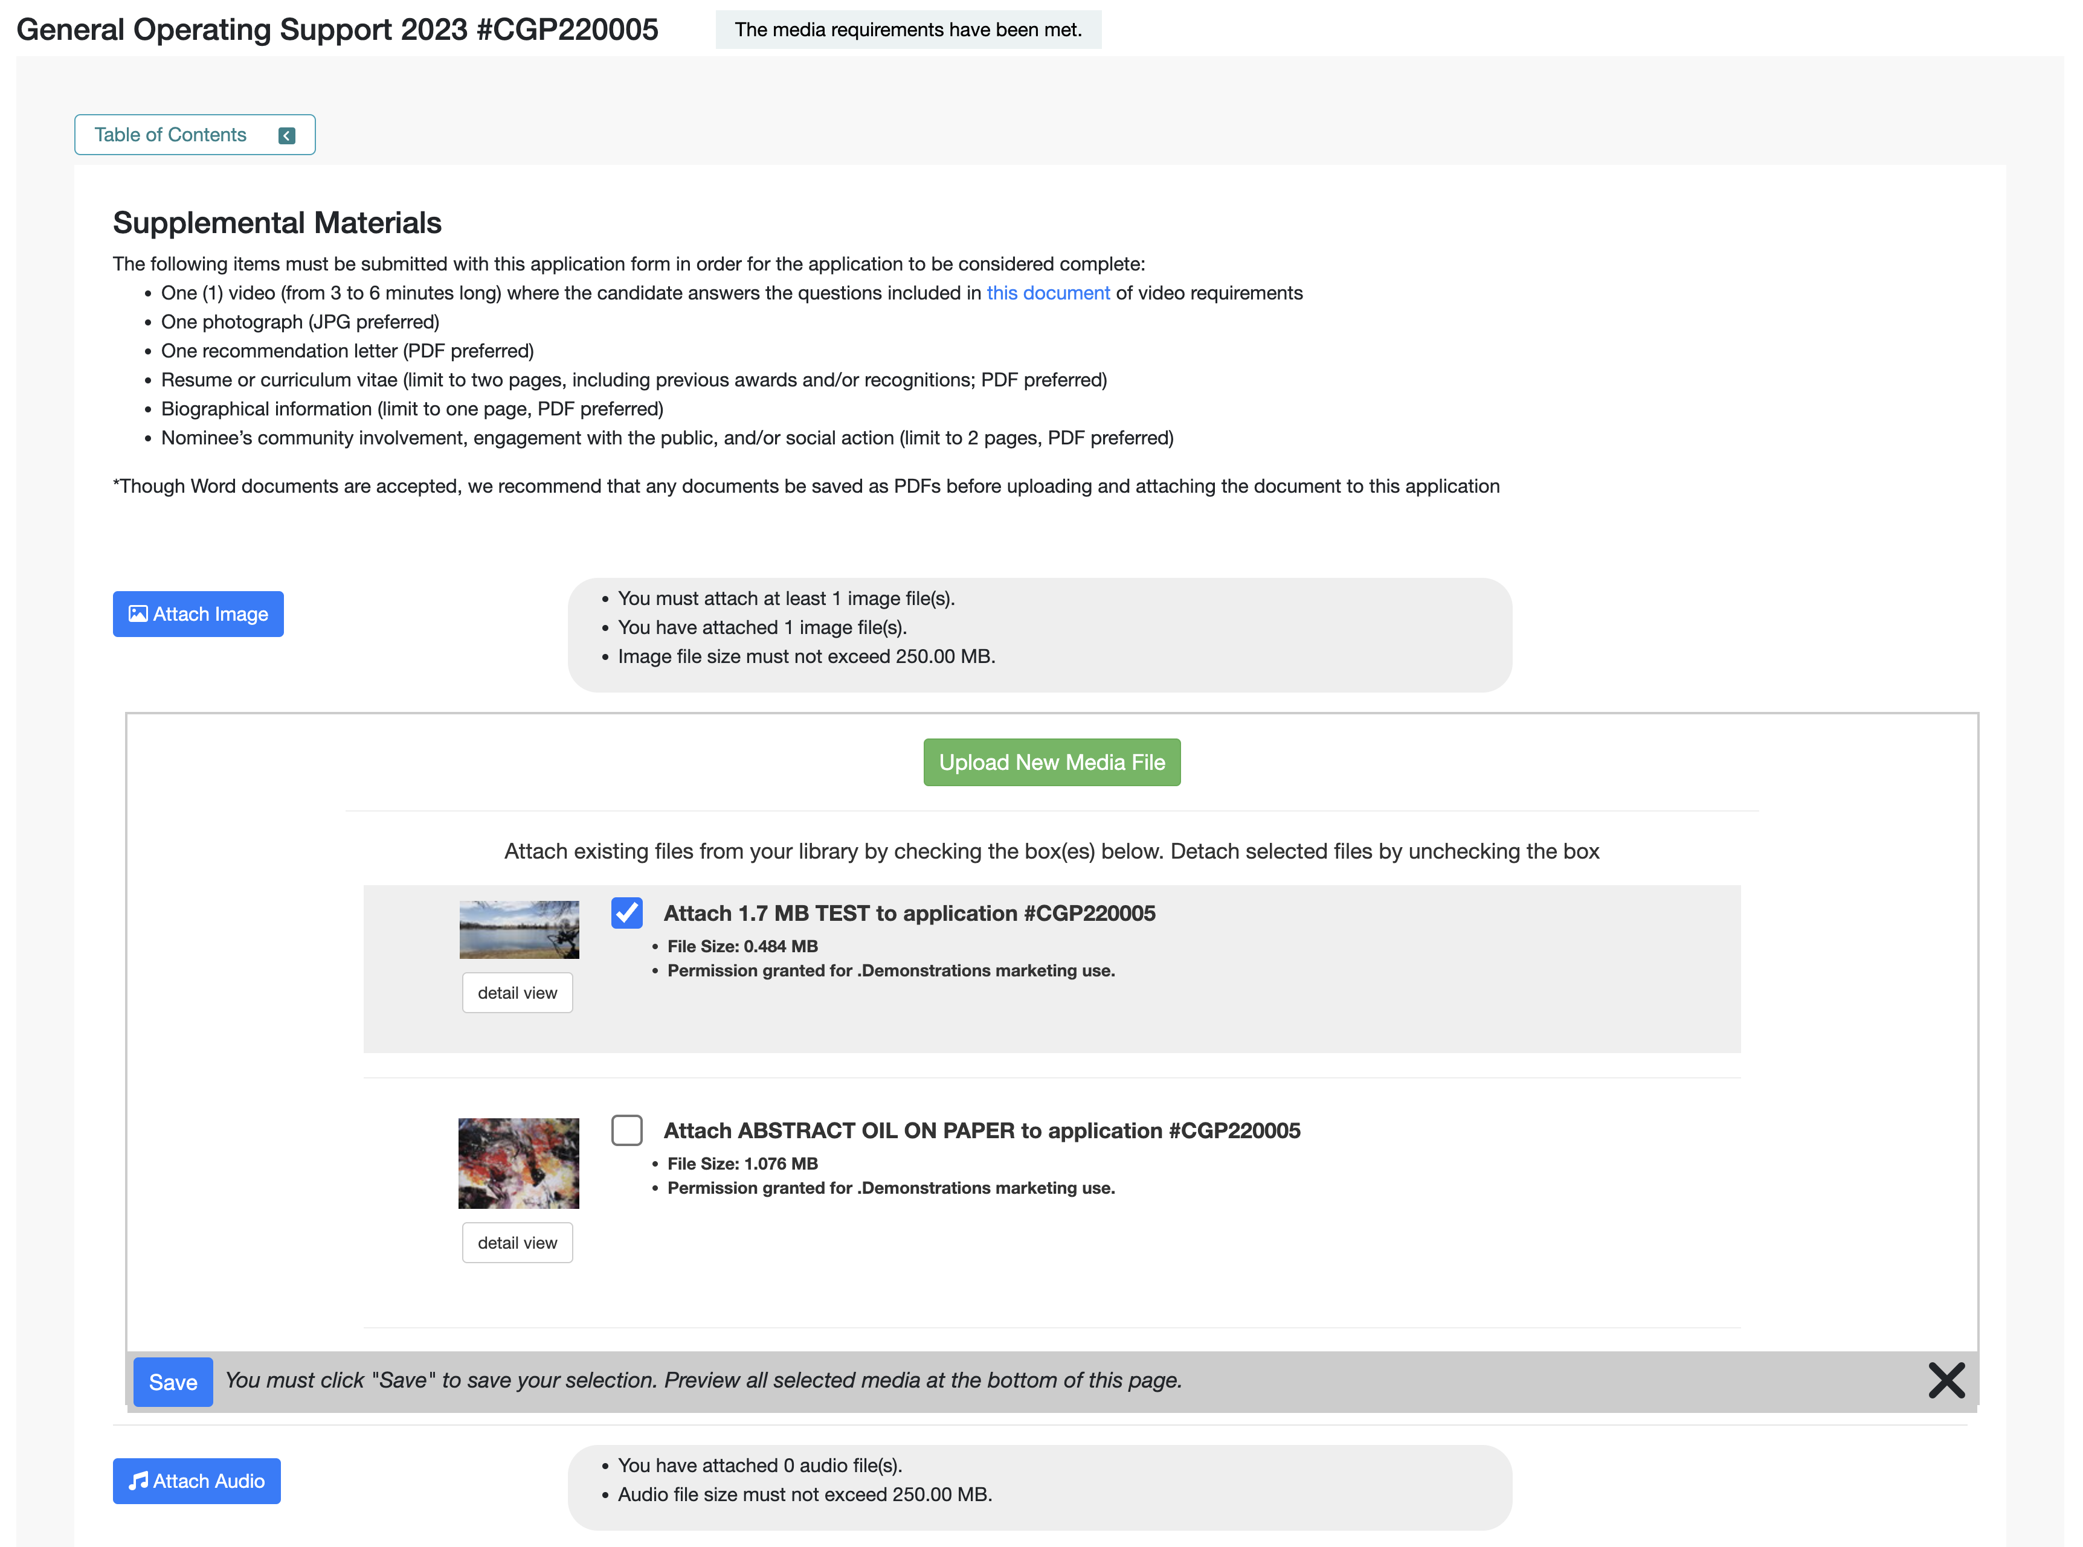
- Click any of the Attach [Media] buttons (ie. Attach Image, Attach Audio, etc.).
- Check the box for the desired file(s). Uncheck a box to detach the file.
  - If you have not yet uploaded your desired media to your Media Library:
    - Click the green Upload New Media file button. This will take you to the upload form in your Media Library.
    - Follow the Media Library instructions to upload your file(s). Upload or modify additional files while in the Media Library.
    - Click the Return to Application button to return to your application, interim, or final report.
    - Click the Attach [Media] button.
    - Check the box for the desired file(s).
- Click Save.
- Repeat as needed for each media type
- Review the Attached Media section at the bottom of the page to verify your selection.

MEDIA LIBRARY

Learn how to use the tools of your library.

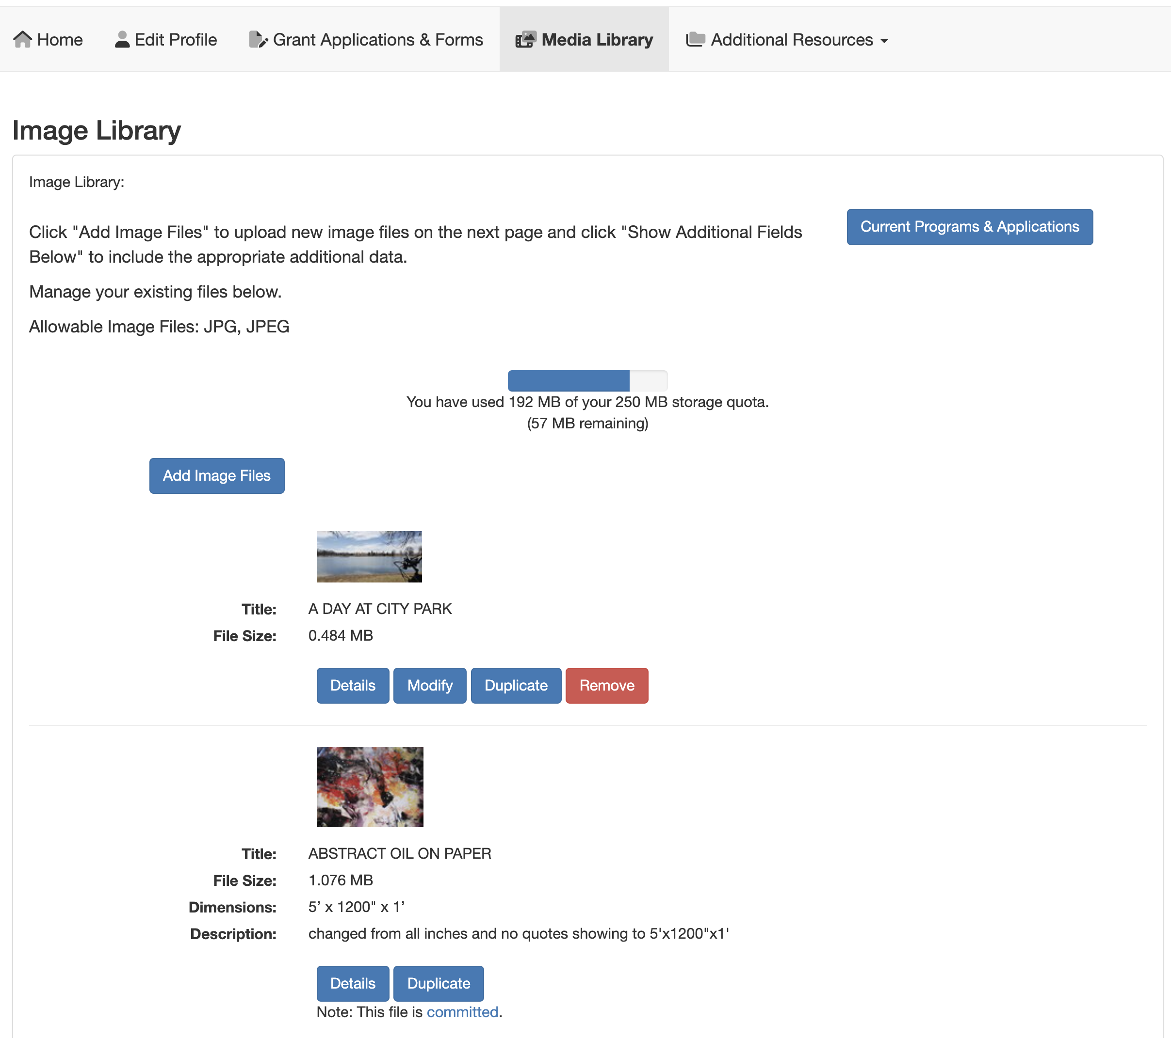

- Use the Details button to review information you included when you uploaded the file.
- Click Modify to edit and save any changes to an existing file.
- Click Duplicate to make a copy of a file.
- Click Remove to delete an existing file from your Media Library. This will free up space to upload additional items.
- If Modify and Remove are not available and you see that the file is committed (as in the second example above), this indicates that the item is currently attached to an application that is In Progress. If you need to modify or remove the item, you will need to either submit the In Progress application or detach the item from the In Progress application.
- Alternatively, you can duplicate the committed item, update the details, change the name, save and attach the modified duplicate to the appropriate form on a Media Library Selection page.

NEXT STEPS

If you are instructed to submit additional reports or forms after submitting your application, follow the steps below to find the appropriate items.
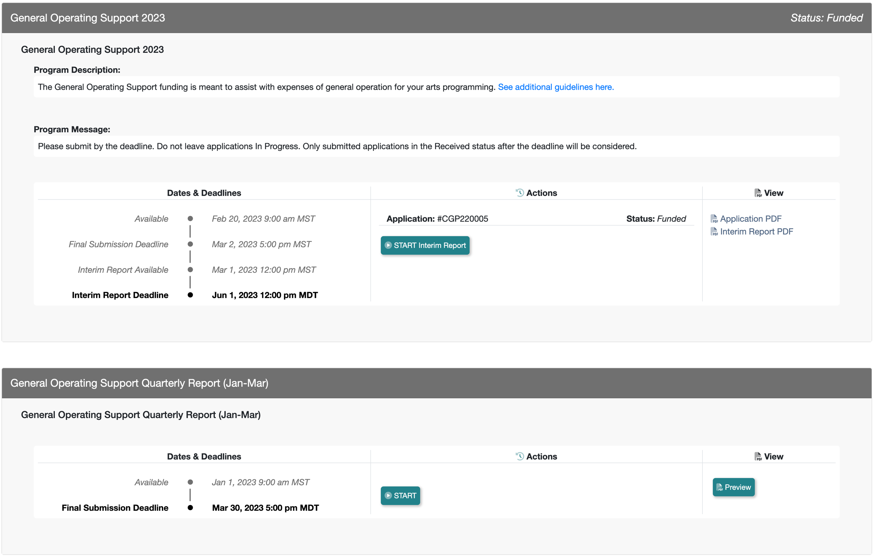
- Watch for communications from your granting agency regarding a possible award, necessary follow-up reports and other items.

- If you are awarded or invited to work on follow up items such as interim or final reports, return to your Grant Applications & Forms tab, locate the cycle and click START or EDIT on the available cycle item, such as the Interim Report in the top example above.

- Alternatively, you may be directed to associated programs, such as General Operating Support Quarterly Report (Jan-Mar) in the bottom of the example above. Locate this associated program and click START or EDIT to work on and submit the form just as you did other forms.

HELP AND GUIDANCE

Your granting agency can create custom text on the Home page and in optional Additional Resource pages. These pages may include additional guidance from your granting agency regarding the way you should use the site.
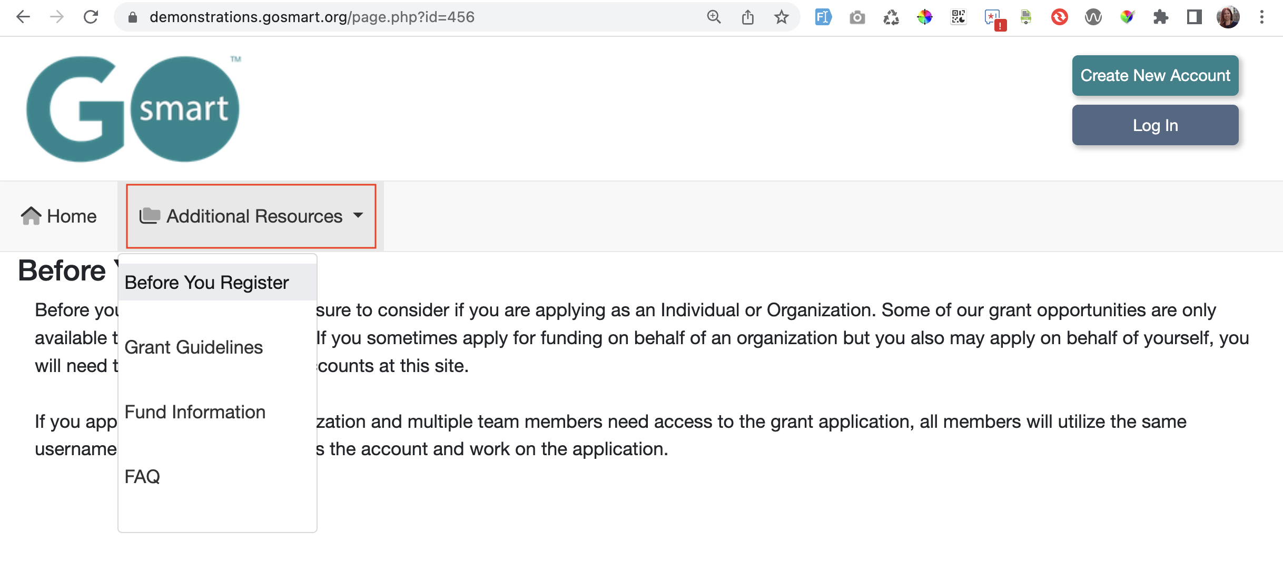
- Follow any guideline or rules as set forth in these areas, shown in the example above.

- If there is no additional help language or resource pages, register or log in and navigate to the Grant Applications & Forms tab to begin working on your application(s)!

For additional information and assistance while using the GO Smart site, please contact the granting agency.

